Task 1: Web Application Security Testing

Security Testing Report

Application Tested: DVWA(Damn Vulnerable Website Application)
Tools Used: OWASP ZAP, Burp Suite, SQLMap
Tested by: M.Sahiti
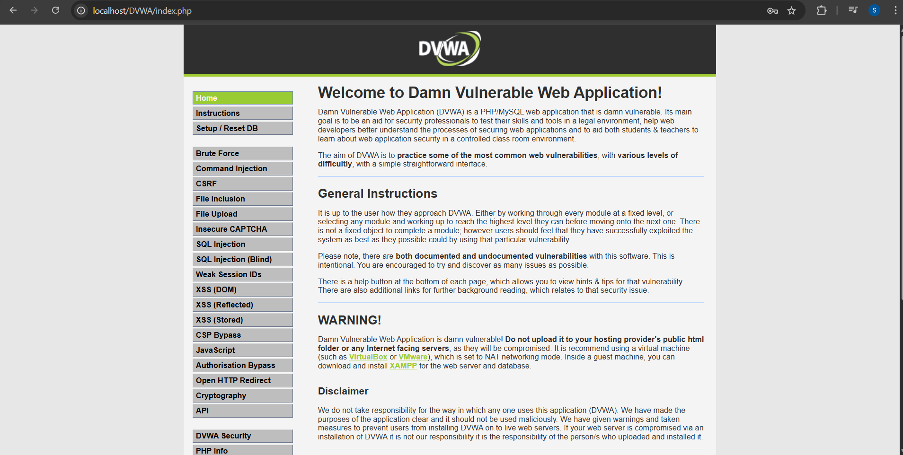

Introduction:
This report documents the security testing performed on DVWA using automated tools like OWASP ZAP and SQLMap. The objective was to identify common web application vulnerabilities and propose suitable mitigation strategies.

Vulnerability Assessment:

SQL Injection:
SQL Injection vulnerabilities allow an attacker to interfere with the queries that an application makes to its database.
Test Case:
Injected 1’OR ‘1’=’1 into the login form and got the User ID’s
Result:
- Login bypass was successful.
- Unauthorized access to user data (e.g., usernames, passwords, emails).
- Dumped database structure using SQLMap.
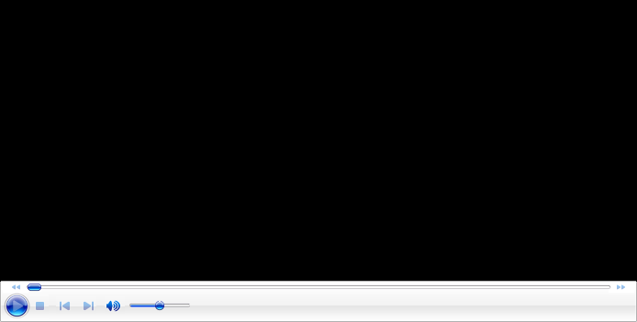

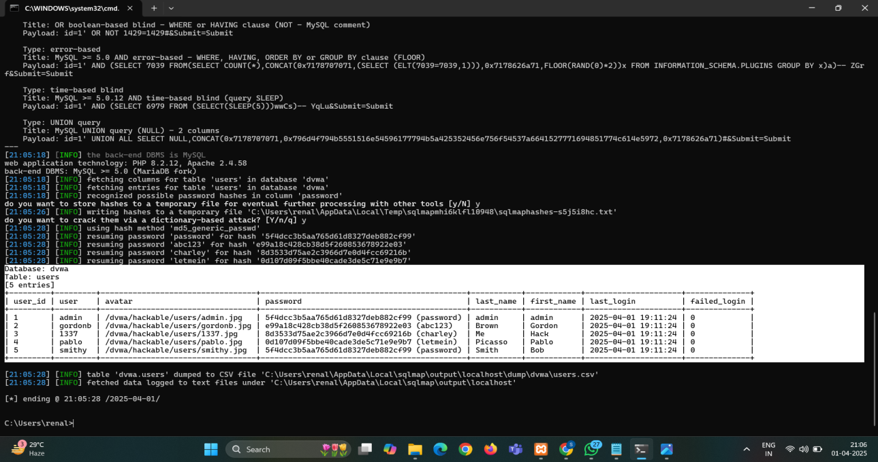
Risk Level: High
Tools Used: SQlMap
Mitigation Strategies:
- Use prepared statements and parameterized queries.
- Validate and sanitize all user inputs.
- Limit database user privileges.
- Implement Web Application Firewalls(WAF).

Cross-Site Scripting(XSS):
XSS allows attackers to inject malicious scripts into webpages viewed by other users.
Test Case:
Injected <script>alert('XSS');</script> into comment and search fields.
Result:
• Reflected XSS on search page.
• Stored XSS in comments section; script executed every time the page loaded.
Risk Level: Medium to High
Mitigation Strategies:
• Encode output (HTML, JavaScript, URL contexts).
• Use Content Security Policy (CSP).
• Validate and sanitize all input fields.

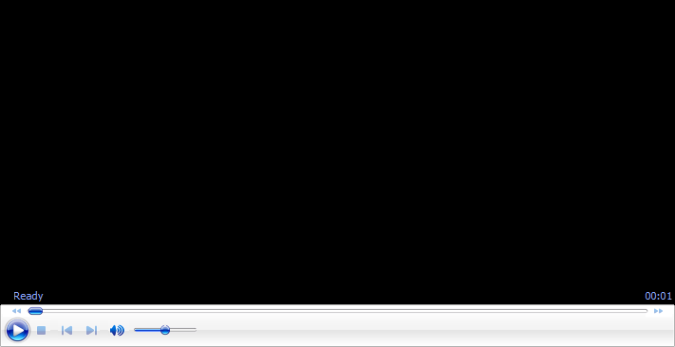

Authentication & Session Management Flaws:
Weaknesses in how the application handles user sessions and login credentials.
Test Case:
- Intercepted session tokens using Burp Suite.
- Scanned the application using OWASP ZAP automated scanner.
- Identified login and session-related endpoints.
- Observed headers and responses for authentication/session indicators.
Tools Used: OWASP ZAP, Burp Suite
Findings Table:
Vulnerability | Risk Level | Description | Suggested Fix
Content Security Policy (CSP) Header Not Set | Medium | Without a CSP, browsers may allow inline scripts, increasing XSS risk. | Add a strong Content-Security-Policy header.
Directory Browsing | Medium | Directory listing allows users to see sensitive or hidden files. | Disable directory listing in the web server configuration.
Hidden File Found | Medium | May indicate access to sensitive files not meant for public. | Remove unnecessary files or restrict access.
Missing Anti-clickjacking Header | Medium | Site can be embedded in iframes, risking clickjacking attacks. | Add X-Frame-Options: DENY or SAMEORIGIN.
Cookie without SameSite Attribute | Low | Cookies without SameSite can be used in CSRF attacks. | Add SameSite=Strict or Lax attribute to cookies.
Server Leaks via "X-Powered-By" Header | Low | Reveals backend technology (e.g., PHP version). | Remove or override X-Powered-By header.
Server Leaks via "Server" Header | Low | Reveals server version (e.g., Apache/2.4.41). | Suppress Server header in web server config.
X-Content-Type-Options Header Missing | Low | Allows browsers to guess MIME types, which can be exploited. | Add header: X-Content-Type-Options: nosniff.
Authentication Request Identified | Info | Indicates login request was found. (Not a vulnerability.) | —
Session Management Response Identified | Info | Shows session tokens are used. (Informational only.) | —
User Agent Fuzzer | Info | Fuzzed using different User-Agent strings. Helps in identifying server behavior. | No action needed unless unusual behavior found.

Result:
- Authentication Request Identified – Login functionality detected; possible attack surface for brute-force or bypass.
- Session Management Response Identified – Session cookies observed, but not marked with security flags.
- Cookie without SameSite Attribute – Increases risk of CSRF attacks.
- Session cookies lack Secure and HttpOnly flags
- No account lockout after multiple failed attempts.
- Predictable session IDs.
Risk Level: High
Risk Summary:
Vulnerability | Risk Level | Exploitability | Impact
Weak Default Credentials | High | Easy | High
Brute Force Vulnerability | High | Easy | High
Lack of MFA | Medium | Moderate | High
Weak Session Management | Medium | Moderate | Moderate

Mitigation Strategies:
- Implement account lockout or CAPTCHA after multiple failed logins.
- Use secure, random session tokens.
- Invalidate session properly on logout.
- Set Secure, HttpOnly, and SameSite attributes on all session cookies.
- Implement multi-factor authentication (MFA).
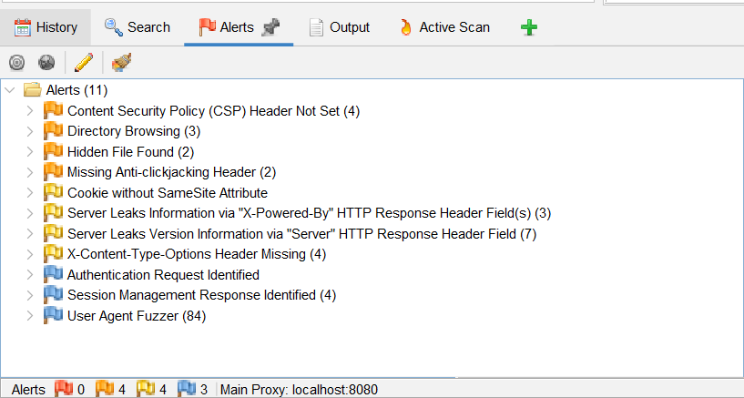

Conclusion:
The DVWA application, by design, is intentionally vulnerable. However, conducting these tests provided valuable insights into identifying and understanding real-world web application vulnerabilities using automated tools. The security assessment revealed multiple critical vulnerabilities, including SQL Injection, Cross-Site Scripting (XSS), and authentication flaws. These issues pose a significant risk to the confidentiality, integrity, and availability of application data and user sessions.
Immediate remediation is strongly recommended. By addressing the identified vulnerabilities and adopting secure coding practices, the application’s overall security posture can be significantly strengthened. Continuous monitoring and periodic security assessments should also be enforced to maintain resilience against evolving threats.

Report Prepared By: M.Sahiti
Contact: sahitim137@gmail.com

